Course hierarchy

Course hierarchies are used by organizations to report on course curricula and those who want to track the improvement of a course as new versions are created. Course hierarchies may be based on a program curriculum, certified training program, level of difficulty of courses, versions of a new course, etc.
Visit the Explorance support center to learn more about the course hierarchy in the MTM interface.
The course hierarchy in MTM can be created with a maximum of five levels and a minimum of two, with the last level being the course. The screenshot below illustrates a 3-level course hierarchy in the MTM interface.
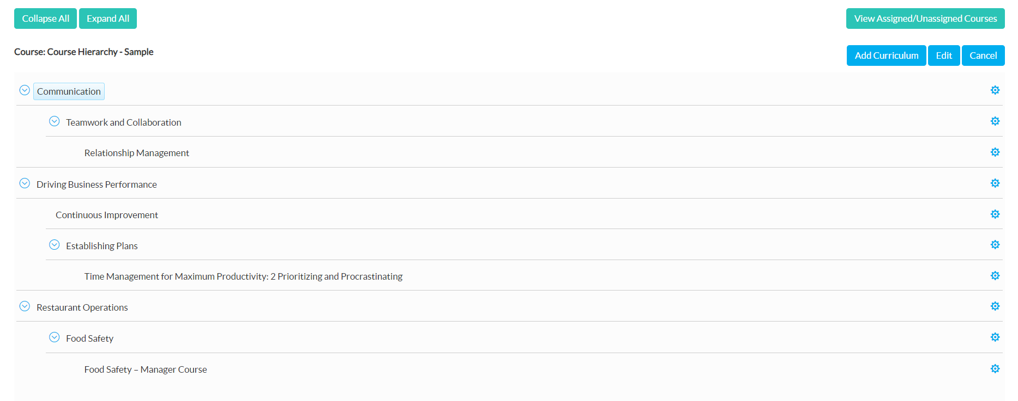
The best way to create a hierarchy in MTM is to first draft it out in a hierarchical format to identify the levels, curriculums, and the courses. The last level of the course hierarchy is the course and the other levels of course hierarchies include curriculum.
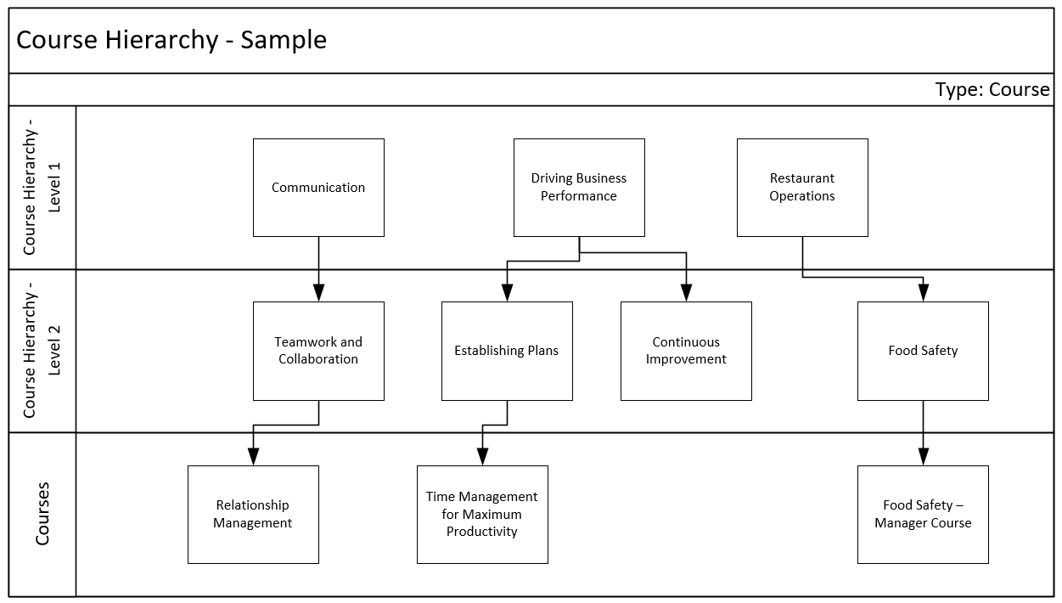
Now to translate that into the API’s schema. Start by defining how many levels will be in your hierarchy and giving each level a name. In the example that is given above there are 3 levels:
<levels>
<level name="Course Hierarchy - Level 1" xid="L1" num="1"/>
<level name="Course Hierarchy - Level 2" xid="L2" num="2"/>
<level name="Courses" xid="L3" num="3"/>
</levels>
Figure 1 Declare the levels under the levels tag.

Within each level, define and name your hierarchy’s curriculum. These curricula will be the buckets you sort courses into in a later step. Please note, only the name of the curricula in your second to last level will appear as Course Groups in your Reports and Dashboards, so be especially mindful when naming them. Your penultimate level must be reserved for courses.
- Curricula in the level 1 are:
- Communication
- Driving Business Performance
- Restaurant Operations
- Curricula in the level 2 are:
- Teamwork and Collaboration
- Continuous Improvement
- Establishing Plans
- Food Safety
- Courses in the level 3 are:
- Relationship Management
- Time Management for Maximum Productivity
- Food safety – Manager Course
Include the courses that are in the last level under the courses tag.
<courses>
<course xid="CO_02" name="Relationship Management" desc="" ol="true" ctype="7" mpname="Azure 101"/>
<course xid="CO_03" name="Time Management for Maximum Productivity " desc="2 Prioritizing and Procrastinating" ol="true" ctype="7" mpname="Azure 101"/>
<course xid="CO_04" name="Food Safety – Manager Course" desc="" ol="true" ctype="7" mpname="Azure 101"/>
</courses>
Figure 2 Declare each course along with its attributes.
Include the curriculums that are in the other levels under the curricula tag. Curriculums in level 2 can be linked to level 1 with the help of parent tag.
<curricula>
<curriculum name="Communication" xid="curr_1" levelxid="L1"/>
<curriculum name="Teamwork and Collaboration" xid="curr_1_1" levelxid="L2" parent="curr_1"/>
<curriculum name="Driving Business Performance" xid="curr_2" levelxid="L1"/>
<curriculum name="Establishing Plans" xid="curr_2_1" levelxid="L2" parent="curr_2"/>
<curriculum name="Continuous Improvement" xid="curr_2_2" levelxid="L2" parent="curr_2"/>
<curriculum name="Restaurant Operations" xid="curr_3" levelxid="L1"/>
<curriculum name="Food Safety" xid="curr_3_1" levelxid="L2" parent="curr_3"/>
</curricula>
Figure 3 Declare each curriculum along with its attributes and link them to curriculums in other levels.

Now link the course to curriculum on the penultimate level using the curriculacourse tag.
<curriculacourse>
<curcourse xid="CO_02" curriculumid="curr_1_1"/>
<curcourse xid="CO_03" curriculumid="curr_2_1"/>
<curcourse xid="CO_04" curriculumid="curr_3_1"/>
</curriculacourse>
Figure 4 Connect the course XID with the corresponding curriculum ID.
<import date="7/15/2021 2:02:06 AM" src="18503">
<vendors>
<vendor xid="23101" name="ProdTest" internal="true"/>
<vendor xid="45444" name="Test Org" internal="false"/>
</vendors>
<courses>
<course xid="CO_02" name="Relationship Management" desc="" ol="true" ctype="7" mpname="Azure 101"/>
<course xid="CO_03" name="Time Management for Maximum Productivity: 2 Prioritizing and Procrastinating" desc="" ol="true" ctype="7" mpname="Azure 101"/>
<course xid="CO_04" name="Food Safety – Manager Course" desc="" ol="true" ctype="7" mpname="Azure 101"/>
</courses>
<coursehierarchies>
<coursehierarchy name="Course Hierarchy - Sample" desc="Test Course Hierarchy">
<levels>
<level name="Course Hierarchy - Level 1" xid="L1" num="1"/>
<level name="Course Hierarchy - Level 2" xid="L2" num="2"/>
<level name="Courses" xid="L3" num="3"/>
</levels>
<curricula>
<curriculum name="Communication" xid="curr_1" levelxid="L1"/>
<curriculum name="Teamwork and Collaboration" xid="curr_1_1" levelxid="L2" parent="curr_1"/>
<curriculum name="Driving Business Performance" xid="curr_2" levelxid="L1"/>
<curriculum name="Establishing Plans" xid="curr_2_1" levelxid="L2" parent="curr_2"/>
<curriculum name="Continuous Improvement" xid="curr_2_2" levelxid="L2" parent="curr_2"/>
<curriculum name="Restaurant Operations" xid="curr_3" levelxid="L1"/>
<curriculum name="Food Safety" xid="curr_3_1" levelxid="L2" parent="curr_3"/>
</curricula>
<curriculacourse>
<curcourse xid="CO_02" curriculumid="curr_1_1"/>
<curcourse xid="CO_03" curriculumid="curr_2_1"/>
<curcourse xid="CO_04" curriculumid="curr_3_1"/>
</curriculacourse>
</coursehierarchy>
</coursehierarchies>
</import>
Figure 5 Xml code to create course hierarchy.

