MTM Connect API – Conceptual relationship

An entity represents a real-world object; we can often identify these as the major objects of the system we are modeling. In our case, entities would be courses, instructors, vendors, locations, classes, responses, demographic responses, enrollments, clients, business units, forms, questions, and question categories. It is important to understand the relationship between the entities. Each entity is connected to another entity using key columns. Based on the relationship between entities the key identifier can be connected to zero or more records in another entity.

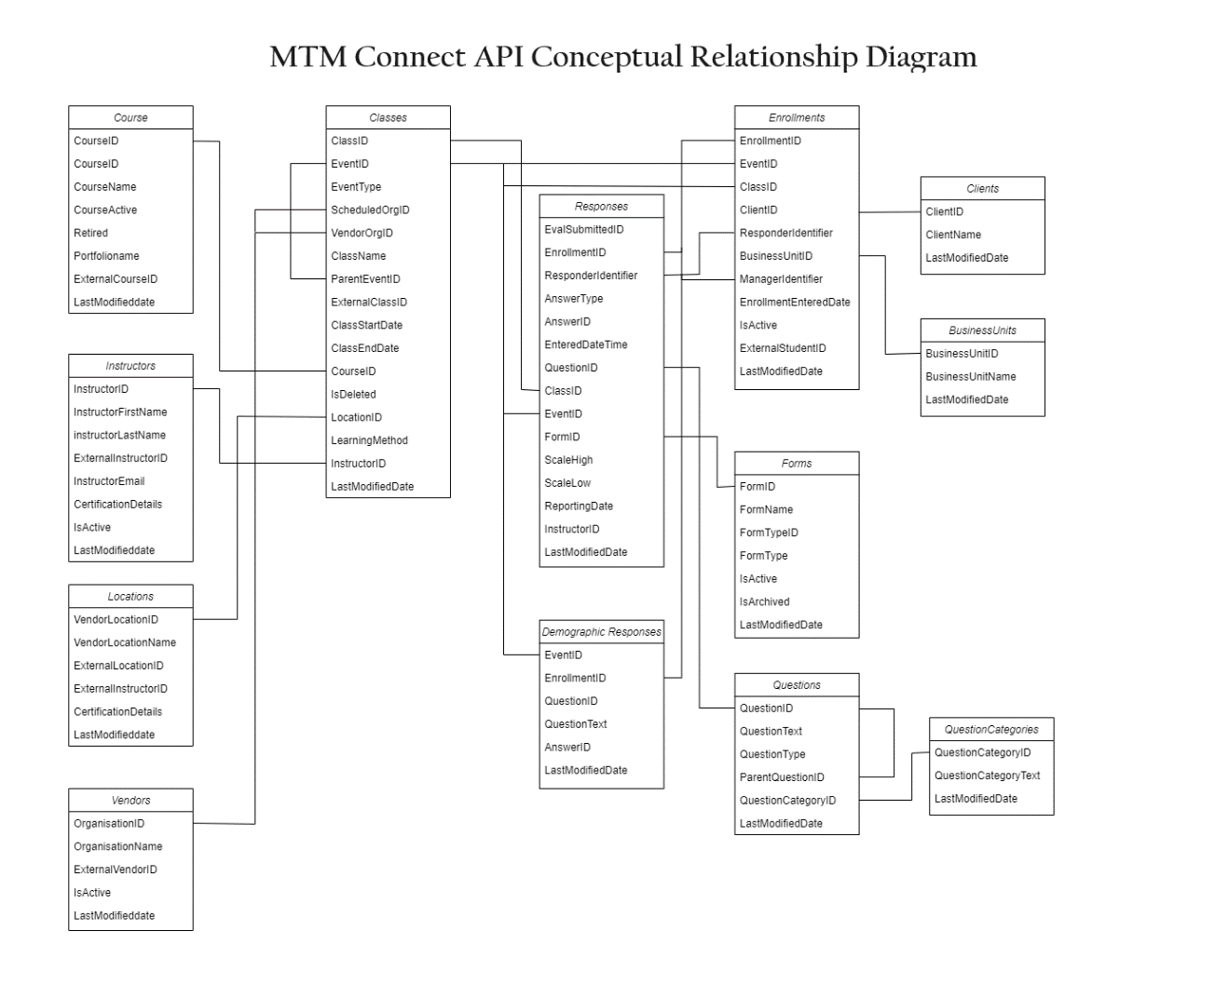

This diagram displays an abstract representation of the various entities and the relationships between them. Think of this diagram as a simple relationship diagram that serves as a graphical representation of entities and their relationships with each other.

|  |  |
| --- | --- |
| **Course** | |
| Course  **CourseID**  CourseName  CourseActive  Retired  Portfolioname  ExternalCourseID  LastModifiedDate  Figure 1 Course entity fields | One of these attributes that may be utilized to specifically identify a course is CourseID. In the XML, the CourseID is referred to as the Course xid.  <courses>  <course xid="CO_01" name="Course 1 - Import V2" desc="An introductory course in MS Office" ol="false" ctype="1" mpname="Azure 101" mtmname="testcourse" xvendor="23101" cprovider="Sample"/>  <course xid="CO_02" name="Course 2 - Import V2" desc="Course 2 - Import V2" ol="true" ctype="7" mpname="Azure 101"/>  </courses>  Table 1 Course entity– sample XML |
| **Location** | |
| Locations  **VendorLocationID**  VendorLocationName  ExternalLocationID  CertificationDetails  LastModifiedDate  Figure 2 Location entity fields | The attribute that can be used to specifically identify a location is VendorLocationID. VendorLocationID is referred to as the location XID in the XML.  <locations>  <location xid="LOC_01" name="Chicago, IL" to="-6" xvendor="23101">  <Certification certname="MCP" id="ImportTest_Cert1"/>  <Certification certname="MCP" id="ImportTest_Cert2"/>  </location>  <location xid="LOC_02" name="Montreal, CA" to="-4"/>  </locations>  Table 2 Location entity– sample XML |

|  |  |
| --- | --- |
| **Vendor** | |
| Vendor  **OrganizationID**  OrganizationName  IsActive  ExternalVendorID  LastModifiedDate  Figure 3 Vendor entity fields | OrganizationID is the attribute that can be used to precisely identify a vendor. In the XML, OrganizationID is referred to as the vendor xid.  <vendors>  <vendor xid="23101" name="ProdTest" internal="true"/>  <vendor xid="45444" name="Test Org" internal="false"/>  </vendors>  Table 3 Vendor entity– sample XML |
| **Instructor** | |
| Instructor  **InstructorID**  InstructorFirstName  InstructorLastName  ExternalInstructorID  InstructorEmail  CertificationDetails  IsActive  LastModifiedDate  Figure 4 Instructor entity fields | The attribute that can be used to specifically identify an instructor is **InstructorID**. In the XML, **InstructorID** is referred to as the instructor xid.  <instructors>  <instructor xid="INS_01" fname="Instructor" lname="01" email="Instructor01@noemail.com" xvendor="23101">  <Certification certname="MCP" id="ImportTest_Cert"/>  </instructor>  <instructor xid="INS_02" fname="Instructor" lname="02" email="Instructor02@noemail.com"/>  </instructors>  Table 4 Instructor entity– sample XML |
| **Client** | |
| Client  **ClientID**  ClientName  LastModifiedDate  Figure 5 Client entity fields | **ClientID** is the attribute that can be used to precisely identify a client. In the XML, **ClientID** is referred to as the client xid.  <clients>  <client xid="Client_01" name="Test client Import V2">  <bunit name="1 Test BU Import V2" xid="BU_01"/>  <bunit name="2 Test BU Import V2" xid="BU_02"/>  <domain name="@test.com"/>  <domain name="@test123.com"/>  </client>  <client xid="Client_03" name="Test client Import V2">  <bunit name="3 Test BU Import V2" xid="BU_03"/>  <bunit name="4 Test BU Import V2" xid="BU_04"/>  </client>  </clients>  Table 5 Client entity- sample XML |

**Class**

The attribute that can be used to specifically identify a class is ClassID. In XML, ClassID is referred to as the class xid.

* A class can be associated with one course whereas a course can be associated with many classes. The course xid in the course entity is referred to as the xcourse attribute of the class entity, which is used to associate a class with a particular course.
* A class can be associated with many instructors and an instructor can be associated with many classes. The instructor xid in the instructor entity is referred to as the xid attribute of the classInstructor entity, which is used to associate a class with a particular instructor.
* A class can be associated with one location. The location xid in the location entity is referred to as the xloc attribute of the class entity, which is used to associate a class with a particular location.
* A class can be associated with one vendor. The vendor xid in the vendor entity is referred to as the xvendor attribute of the class entity, which is used to associate a class with a particular vendor.Students are enrolled in a class and so the student is a part of the class entity. The client xid in the client entity is referred to as the xclient attribute of the student entity, which is used to associate a student with a particular class.

|  |  |
| --- | --- |
|  | |
| Figure 6 Relationship between class, course, location, vendor, instructor, and client. | <classes>  <class xid="CLS_1" sd="06/02/2021" ed="06/02/2021" xcourse="CO_01" lm="1" xloc="LOC_01" xvendor="23101" classname="Import V2 Class" survey="true">  <classInstructor xid="INS_01"/>  <classInstructor xid="INS_02"/>  <survey sid="31496" email="true"/>  <survey sid="31497" email="true"/>  <student xid="STD_01" firstname="abc" lastname="xyz" identifiertype="email" identifier="sampleemail@xyz.com" jt="1" langpref="fr" xclient="Client_01" xbunit="" cancel="1">  <Manager xid="Manager_XID" email="noemail@xyz.com" name="test manager" langpref="en"/>  </student>  <student xid="STD_02" firstname="def" lastname="ghi" identifiertype="email" identifier="sampleemail1@xyz.com" jt="5" langpref="en">  <Manager xid="Manager_XID" email="noemail@xyz.com" name="test manager" langpref="en"/>  </student>  </class>  </classes>  Table 6 Class entity - sample XML |