Regional hierarchy

**Regional hierarchies** are used for organizations that manage several locations. You can create, edit, and remove regional groupings. Regions may be created based on geographical location, training volume, or another attribute as you see fit. An example is to create a hierarchy based on different continents, and break each continent down to countries, states, and cities.

Visit the [Explorance support center](https://onlinehelp.explorance.com/mtm/Content/configure/hierarchies-overview.htm?tocpath=User%20guides%7CConfigure%20data%20collection%7CClass%20management%7CHierarchies%7C_____1) to learn more about the regional hierarchy in the MTM interface.

The regional hierarchy in MTM can be created with a maximum of five levels and a minimum of two. MTM provides the ability to add multi-level regional hierarchy, with the last level being the location. The screenshot below illustrates a 3-level regional hierarchy in the MTM user interface.

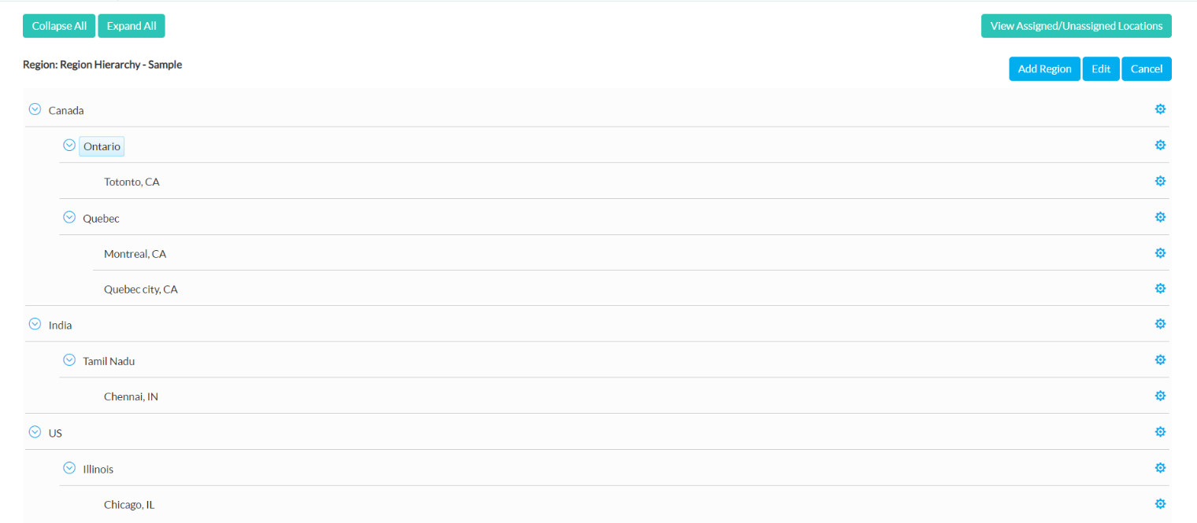

The best way to create a hierarchy in MTM is to first draft it out in a hierarchical format to identify the levels, regions, and locations. The last level of the regional hierarchy is the location, and the other levels of regional hierarchies include region. In the example that is given above there are 3 levels:

<levels>

<level name="Region Hierarchy - Level 1" xid="RH_L1" num="1"/>

<level name="Region Hierarchy - Level 2" xid="RH_L2" num="2"/>

<level name="Locations" xid="Loc_L3" num="3"/>

</levels>

Figure Declare the levels under the levels tag.

1. Regions in level 1 are:
2. Canada
3. India
4. US
5. Regions in level 2 are:
6. Ontario
7. Quebec
8. Tamil Nadu
9. Illinois
10. Locations in level 3 are:
11. Toronto, CA
12. Montreal, CA
13. Quebec City, CA
14. Chennai, IN
15. Chicago, IL

Include the locations that are in the last level under the locations tag.

<locations>

<location xid="LOC_01" name="Chicago, IL" to="-6" xvendor="23101"/>

<location xid="LOC_02" name="Montreal, CA" to="-4"/>

<location xid="LOC_03" name="Chennai, IN" to="5"/>

<location xid="LOC_04" name="Quebec City, CA" to="-4"/>

<location xid="LOC_05" name="Totonto, CA" to="-4"/>

</locations>

Figure 2 Declare each location along with its attributes.

Include the regions that are in the other levels under the curricula tag. Regions in level 2 can be linked to level 1 with the help of parent tag.

<regions>

<region name="US" xid="reg_1" levelxid="RH_L1"/>

<region name="Illinois" xid="reg_1.1" levelxid="RH_L2" parent="reg_1"/>

<region name="Canada" xid="reg_2" levelxid="RH_L1"/>

<region name="Quebec" xid="reg_2.1" levelxid="RH_L2" parent="reg_2"/>

<region name="Ontario" xid="reg_2.2" levelxid="RH_L2" parent="reg_2"/>

<region name="India" xid="reg_3" levelxid="RH_L1"/>

<region name="Tamil Nadu" xid="reg_3.1" levelxid="RH_L2" parent="reg_3"/>

</regions>

Figure 3 Declare each region along with its attributes and link them to regions in other levels.

Now link the location to region on the penultimate level using the regionlocation tag.

<regionlocations>

<regionlocation xid="LOC_01" regionid="reg_1.1"/>

<regionlocation xid="LOC_02" regionid="reg_2.1"/>

<regionlocation xid="LOC_04" regionid="reg_2.1"/>

<regionlocation xid="LOC_05" regionid="reg_2.2"/>

<regionlocation xid="LOC_03" regionid="reg_3.1"/>

</regionlocations>

Figure 4 Connect the location XID with the corresponding region ID.

<import date="7/15/2021 2:02:06 AM" src="18503">

<vendors>

<vendor xid="23101" name="ProdTest" internal="true"/>

<vendor xid="45444" name="Test Org" internal="false"/>

</vendors>

<locations>

<location xid="LOC_01" name="Chicago, IL" to="-6" xvendor="23101"/>

<location xid="LOC_02" name="Montreal, CA" to="-4"/>

<location xid="LOC_03" name="Chennai, IN" to="5"/>

<location xid="LOC_04" name="Quebec city, CA" to="-4"/>

<location xid="LOC_05" name="Totonto, CA" to="-4"/>

</locations>

<locationhierarchies>

<locationhierarchy name="Region Hierarchy - Sample" desc="Region Hierarchy">

<levels>

<level name="Region Hierarchy - Level 1" xid="RH_L1" num="1"/>

<level name="Region Hierarchy - Level 2" xid="RH_L2" num="2"/>

<level name="Locations" xid="Loc_L3" num="3"/>

</levels>

<regions>

<region name="US" xid="reg_1" levelxid="RH_L1"/>

<region name="Illinois" xid="reg_1.1" levelxid="RH_L2" parent="reg_1"/>

<region name="Canada" xid="reg_2" levelxid="RH_L1"/>

<region name="Quebec" xid="reg_2.1" levelxid="RH_L2" parent="reg_2"/>

<region name="Ontario" xid="reg_2.2" levelxid="RH_L2" parent="reg_2"/>

<region name="India" xid="reg_3" levelxid="RH_L1"/>

<region name="Tamil Nadu" xid="reg_3.1" levelxid="RH_L2" parent="reg_3"/>

</regions>

<regionlocations>

<regionlocation xid="LOC_01" regionid="reg_1.1"/>

<regionlocation xid="LOC_02" regionid="reg_2.1"/>

<regionlocation xid="LOC_04" regionid="reg_2.1"/>

<regionlocation xid="LOC_05" regionid="reg_2.2"/>

<regionlocation xid="LOC_03" regionid="reg_3.1"/>

</regionlocations>

</locationhierarchy>

</locationhierarchies>

</import>

Figure 5 Xml code to create regional hierarchy.